GAN Notes
- https://medium.com/beyondminds/advances-in-generative-adversarial-networks-7bad57028032 (Advances in Generative Adversarial Networks)

Introduction
- they can learn to mimic data
- are used for:
- removing artefacts
- super resolution
- pose transfer
- image translation (example below)

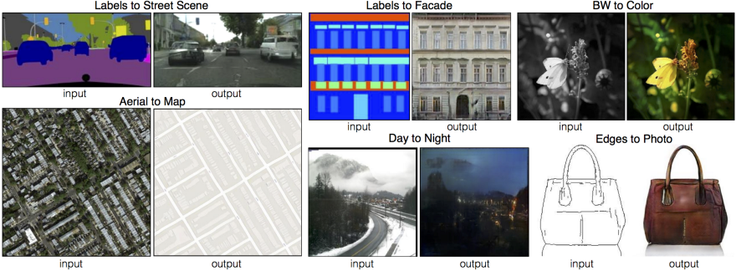
source : https://phillipi.github.io/pix2pix/

Drawbacks of using GANs – An Overview

- Mode Collapse
Generator learns to produce samples with extremely low variety.
- The generator produces the belong to a limited set of modes
- The discriminator figures this out
- The generator locks on to another mode
- CYCLE repeats indefinitely – limiting the diversity of generated samples (for more examples: http://aiden.nibali.org/blog/2017-01-18-mode-collapse-gans/)
- Convergence
- Quality
- Metrics

